**Chapter 1 . Introduction**

Introduction

­­­­­­­­­­­­­­­­­­_________________________________________________________________________________________________________________________

In recent years, computer science has demonstrated great potential in the sport fields. For example, computer vision-based virtual reality was used for sports posture correction, a computer visiondriven evaluation system was adopted for decision-making in sports training, and object detection was used in sports analysis. Sports analysis is crucial for improving athletes’ performance.

We suppose that every country has its main sport, but in India cricket is a religion. I remember watching a debate on a local television channel, not so long ago about why Indians aren't able to make the cut in sports other than cricket. Things are changing in India though. Wolverhampton Wanderers have linked up with an I-League team and Arsenal have expressed an interest and have also come down to India to do some recruiting. It is reported that three boys have been selected to train at Arsenal for a certain period, and this by itself is a massive achievement for us Indians. Indians have to become more open-minded about sports like football. The opportunities are limited for the foreseeable future but there has to be a start somewhere. So, the main idea behind this project is to make people aware about football and its various aspects. Such as its different rules, different leagues, Qualifications for champions-league, champions league itself, different players and there statistics.

**1.1 Overview**

While Football is becoming an important area of activity, there is a need of management systems which organize the football players with their details in proper manner. The project will be covering this part and is a dynamic in nature.

A system is made in such a way that it will classify the player on the basis of a photograph or name which will provide all the details and statistics about that player. In addition, the user can find out the all the leagues and clubs present currently with the help of the available links on our website. It is a easiest platform for all football fans to know the all details about a player.

**1.2 Background and Motivation**

Football refers to a number of sports that involve, to changeable degrees, kicking a ball with the foot to score a goal. The most popular of these sports worldwide is association football, more commonly known as just **“Football”**or **“Soccer”**. Football is much loved sport event for millions of people throughout the world. The objectives of the game is **to score by getting the ball in to the opponents goal.**

Various forms of football can be identified in history, often as popular peasant games. Modern codes of football can be traced back to the codification of these games at English public schools in the 18th and 19th centuries. It is an exciting sport that provides many physical as well as mental challenges. To truly derive the greatest fun and enjoyment from playing soccer, you should prepare for the demands that the game will require of you.

China was the first country to actually write about a game that involving kicking around object in to a goal and that game was played more than 4,000 years ago. The game was called **Tue-Chu,**and it was played for the Emperor’s birthday.

As we know in today, Football was shaped during the 1960s and increased media coverage and TV broadcasting made the game far more popular than it ever was.

As Soccer/Football is one of the most popular sport in the world. So our motivation behind this project was to achieve comparable results to existing methods.

* 1. **Problem Statement and Objectives**

In our country football is getting popular but most of the people didn't properly understand the game so it is hard for them to connect with the game. For example people doesn't know about different leagues and the clubs that play on these leagues so it is difficult to keep track of things. They are not fully aware of rules and regulations of the game and most of the times just know about one or two clubs and very limited no. of players. As a result of these they are not aware of the full potential, passion and joy of this game.

The objective is that our website will be promoting the football sport related activities and will give the information about all the leagues and clubs present in football. The purpose is to develop a model using which user can identify the player and its statistics based on the past data. Over time, the interest of sports clubs in issues and technologies belonging to Artificial Intelligence is growing. The goal is to implement a system capable of providing strategic indications to coaches, thanks to the modelling and techniques of Machine Learning and to develop a new gaming experience for fans. It is a easiest platform for all football fans through which user can search and identify the player, find out the best ones and all the rules and positions present in football. Our project is just an initiative. It will be made to more further and developed work of art.

**1.4** **Scope of the Project**

As there is less awareness and knowledge of football in India, so our motive is to create awareness and provide the correct knowledge to the people. Career in football, which is also recognized as soccer, is now a global industry of multi-billion-pound, which indicates there are more footballrelated jobs than ever before. Football is no longer acknowledged as a sport with no future. In India, there are several universities offering programs in sports at PG and UG levels. Academies like All India Football Federation, Goa Regional Academy, Tata Football train the students in the sport and equip the students with the essential skills. University Campus of Football Business or UCFB is the world first in sports education, offering university degrees in football as well as other sports industries. The average pay of around 3 Lakhs is earned by an entry-level football player with 1-3 years of experience.

Football is gaining momentum and also getting nationwide attention with the start of the Indian Super League. It has inaugurated some considerable changes in Indian football. Nowadays, many youngsters or new faces are getting opportunities to play football, grass-roots level courses are also begun across India. Times have evolved, and so has the perception of football and other sports in India. A career in football is not only restricted to the sports industry and opens opportunities in the advertising, media and education sectors. Future scope of football may be like automated commentary.

**1.5 Team Organization**

* **Asit Joshi:** I worked on backend of the project , made the html templates and did styling of the website , and also applied javascript. I also worked on some of the backend work.
* **Ayush Choudhary:** I also worked on frontend of project ,and did styling of the webpages and also helped in debugging the code and helped in documentation work too.
* **Deepakshi Choudhary:**

Along with doing preliminary investigation and understanding the limitations of current system, I studied about the topic and its scope and surveyed various research papers related to the tourism management system and the technology that is to be used. Documentation is also a part of the work done by me in this project. Also, worked on backend and studied about it.

* **Deependra Singh Parihar:**

I investigated and found the right technology and studied in deep about it. Implementation logic for the project objective and coding of internal functionalities are done by me. Also , worked on backend design for storing results in database for maintaining logs. Some part of the documentation was also done by me.

**1.6 Report Structure**

The project ***Football Player Recognition and Analysis System*** is primarily concerned with the **management of football player and their details** and whole project report is categorized into five chapters.

Chapter 1: Introduction- introduces the background of the problem followed by rationale for the project undertaken. The chapter describes the objectives, scope and applications of the project. Further, the chapter gives the details of team members and their contribution in development of project which is then subsequently ended with report outline.

Chapter 2: Review of Literature- explores the work done in the area of Project undertaken and discusses the limitations of existing system and highlights the issues and challenges of project area. The chapter finally ends up with the requirement identification for present project work based on findings drawn from reviewed literature and end user interactions.

Chapter 3: Proposed System - starts with the project proposal based on requirement identified, followed by benefits of the project. The chapter also illustrate software engineering paradigm used along with different design representation. The chapter also includes block diagram and details of major modules of the project. Chapter also gives insights of different type of feasibility study carried out for the project undertaken. Later it gives details of the different deployment requirements for the developed project.

Chapter 4: Implementation - includes the details of different Technology/ Techniques/ Tools/ Programming Languages used in developing the Project. The chapter also includes the different user interface designed in project along with their functionality. Further it discuss the experiment results along with testing of the project. The chapter ends with evaluation of project on different parameters like accuracy and efficiency.

Chapter 5: Conclusion - Concludes with objective wise analysis of results and limitation of present work which is then followed by suggestions and recommendations for further improvement.

**Chapter 2 . Review of Literature**

Review of Literature

_________________________________________________________________________________________________________________________

**Football** (also known as **association football** or **soccer**) is a team sport played between two teams of 11 players each. It is widely considered to be the most popular sport in the world. A ball game, it is played on a rectangular grass field, or occasionally an artificial turf, with a goal at each end of the field. The object of the game is to score by manoeuvring the ball into the opposing goal; only the goalkeepers may use their hands or arms to propel the ball in general play. The team that scores the most goals by the end of the match wins. If the score is tied at the end of the game, either a draw is declared or the game goes into extended time, depending on the format of the competition.

The modern game was codified in [England](https://www.cs.mcgill.ca/~rwest/wikispeedia/wpcd/wp/e/England.htm) following the formation of the Football Association, whose 1863 Laws of the Game created the foundations for the way the sport is played today. Football is governed internationally by [Fédération Internationale de Football Association](https://www.cs.mcgill.ca/~rwest/wikispeedia/wpcd/wp/f/FIFA.htm) (FIFA). The most prestigious international football competition is the [World Cup](https://www.cs.mcgill.ca/~rwest/wikispeedia/wpcd/wp/f/FIFA_World_Cup.htm), held every four years. This event, the most widely viewed and famous in the world, boasts twice the audience of the Summer Olympics.

**2.1** **Preliminary Investigation**

**2.1.1** **Current System and Its Limitations**

**1. GOAL:**

GOAL brings you all the breaking news and the latest scores from the world’s best leagues and biggest tournaments.

Merits: Has a good interface, Lots of content, great layout and easy to navigate. We can also choose our favourite teams and leagues.

Demerits: Shows a lot of ads. The featured section doesn't work anymore. Only premier league clubs get the priority.

Reference link: https://www.goal.com/en-in

**2. ONEFOOT BALL:**

OneFootball is a platform-based football media company. The OneFootball app features live-scores, statistics and news from 200 leagues in 12 different languages covered by a newsroom located in Berlin.

Merits: It is really good that how many sources that this app gets its data and news articles from. Stats, reviews, news, transfers and mini clips are great.

Demerits: 1. You can't lookup each fixture of each club, only the next upcoming match for each club can be viewed. Matches are only by competition and you have to click on specific matchday.

2. There's no information on TV broadcasts channels.

Reference link: https://onefootball.com/en/home

**3. 433: THE HOME OF FOOTBALL:**

With more than 60 million followers worldwide and 5+ billion impressions per month, 433 is the home of football. Born out of a passion for the beautiful game, 433 is the embodiment of football culture. By positioning ourselves inside the locker room, It has become part of the team and equal to the players. This gives them access to the best moments football has to offer.

Merits: 433 is one of the largest social sports communities in the world. Bringing you the latest news fast. The funniest clips and the most remarkable background stories are also brought to you by 433. 433 is not your average sports news site. A high dose of humor and tongue-in-cheek style, that is 433.

Demerits: They do not talk about rules and basic knowledge of football they just provide the news and social media content related to football world.

Reference link: https://www.4 33football.com/

**4. PREMIER LEAGUE:**

Premierleague.com is a website containing all the information stats and details about premier league. It has everything related to premier league as it is considered to be the toughest league in the world.

Merits: Major merit of this website is that it provides everything related to the premier league at a place. All the score lines, future fixtures and transfer market news at one place

Demerits: The main demerit of this website is it only report about premier league. It does not concern with other leagues and national matches.

Reference link: https://www.premierleague.com/

**5. FIFA:**

It is the official site of the international governing body of football with news, national associations, competitions, results, fixtures, development organization, world rankings, statistics, the international football association board, history, laws of the game, publications, downloads, and contact details.

Merits: FIFA also include various information regarding the football related information as well as the current affair in football league, it also gives us live score of matches that are held all over the world in specific league, Fifa. Com has also an official Apps that you can download from play store.

Demerits: It does not cover small leagues such as Indian Super League and does not provide Indian football details it solely focuses on main players, their activity and successful clubs.

Reference link: <https://www.fifa.com/>

* 1. **Requirement Identification and Analysis for Project**

Significant work has been done in the field of web development ; however, it is not easy to achieve desired results. The review of literature leads to draw certain major findings which are as under:

* When it comes to football, It is surprising to see how a team is able to win a football match against a stronger opponent. At times, viewers get to predict the score of the match by observing team players(their capabilities and strength).
* Football statistics have evolved notoriously in recent years due to automatic or semi-automatic detection technologies that provide high-fidelity data streams for each match based on video recordings or observations made with various types of fixed and mobile sensors.
* We have prepared a dataset of some players which is used to give the details to the user when he uploads a image of the player.

**2.2.1 Conclusion**

This chapter reviews the literature surveys that have been done during the research work. The related work that has been proposed by many researchers has been discussed. After surveying the existing systems, finding out the advantages and disadvantages , we have decided to make the Football Player Recognition and Analysis system which overcomes disadvantages of the existing systems to some extent.

**Chapter 3. Proposed System**

Proposed System

_________________________________________________________________________________________________________________________

**3.1 The Proposal**

The proposal is to deploy a system which is designed to be more efficient than the manual system. It invokes all base tasks that are now carried out manually, such as the uploading the image and get all the information and statistics of the player which is added advantage. The proposed System is completely computer-based application. Information of the player and the leagues amd clubs can be searched and displayed without taking any significant time.

**3.2 Benefits of the Proposed System**

The current system had a lot of challenges that are overcome by this system :

* Gives accurate information of the player
* Gives information about various leagues and clubs
* Provides statistics in different forms
* Easiest platform for searching the player
* Gives knowledge about football in brief

**3.3 Block Diagram**

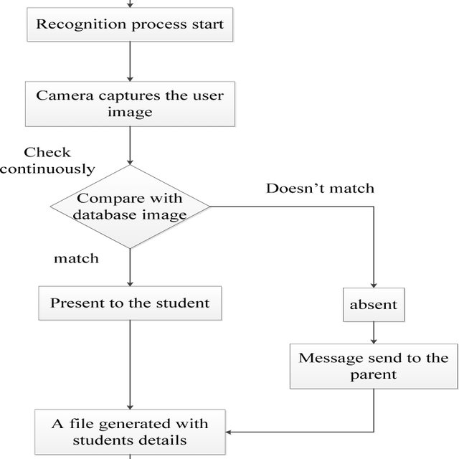

**Fig 3-1 : Block Diagram**

**3.4 Feasibility Study**

A feasibility study is an analysis of how successfully a system can be implemented, accounting for factors that affect it such as economic, technical and operational factors to determine its potential positive and negative outcomes before investing a considerable amount of time and money into it.

**3.4.1 Technical**

For the Football Player Recognition and Analysis management, there is a need to make a dynamic and interactive website which gives user a interface to get the information of the player just by uploading the image. For this, Node js is used, which is a cross-platform, open-source server environment that can run on Windows, Linux, Unix, macOS, and more. Node.js is a back-end JavaScript runtime environment, runs on the V8 JavaScript Engine, and executes JavaScript code outside a web browser.

**3.4.2 Economical**

**3.4.3 Operational**

The main motto of our system is the user can perform all the operations possible easily and get the desired information about the players. The system is able to do that accurately and efficiently making the system operationally feasible.

**3.5 Design Representation**

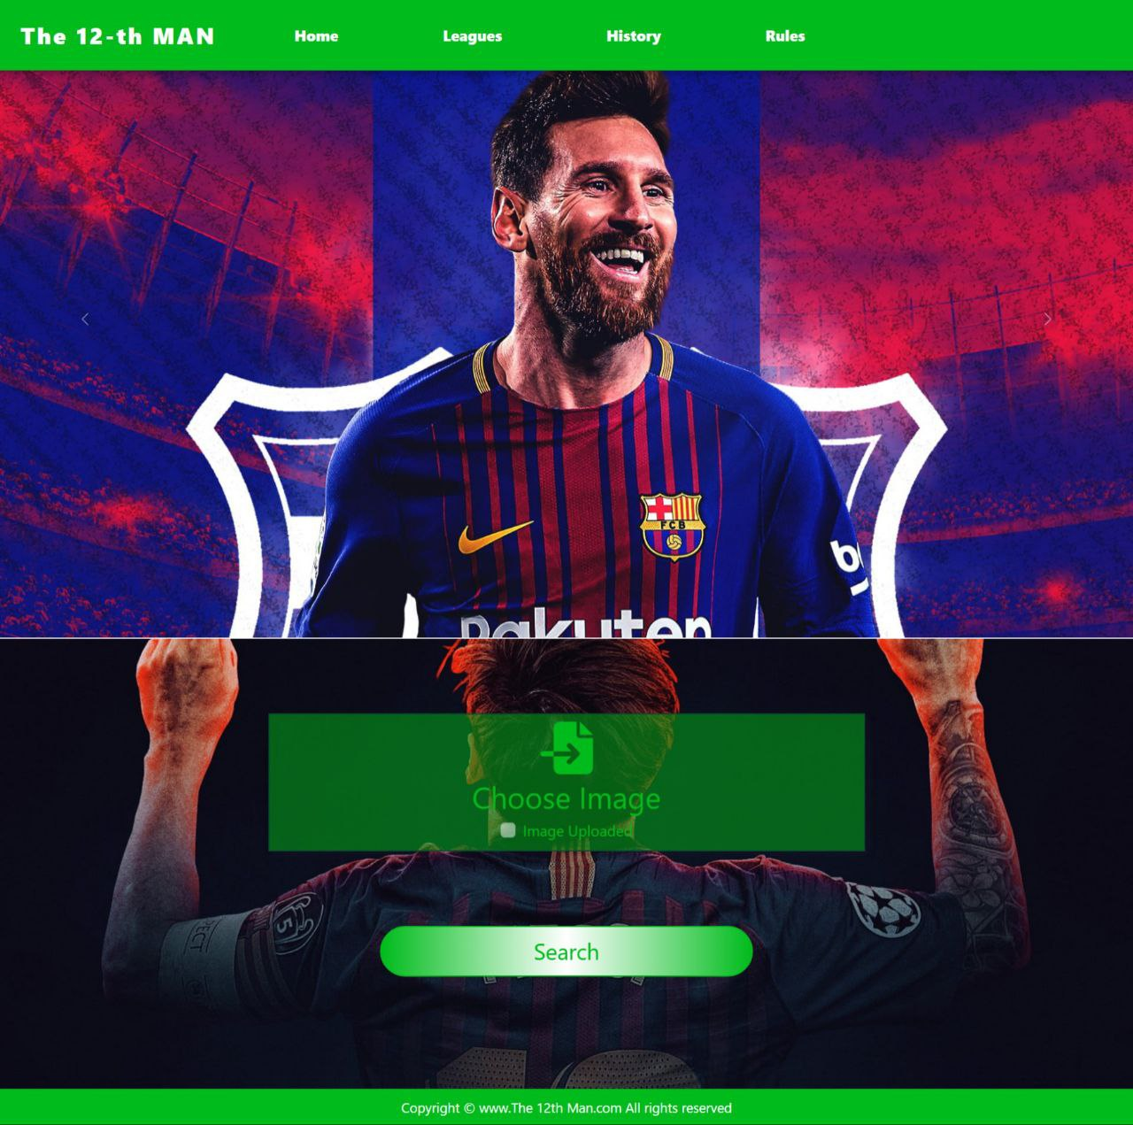

**Fig 3-2: Home page**



**Fig 3-3: Upload image page**

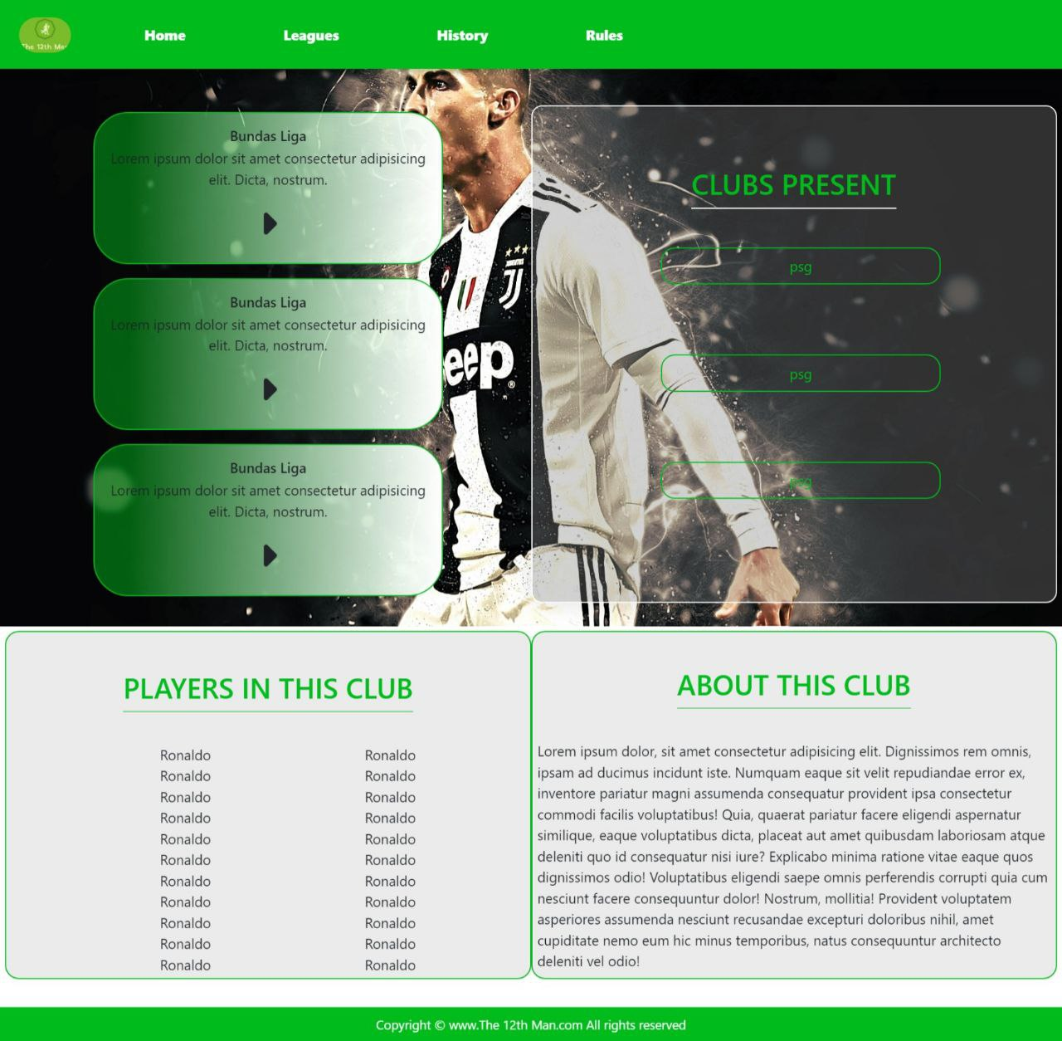

**Fig 3-4:** **Leagues page**



**Fig 3-5:** **Clubs Information page**

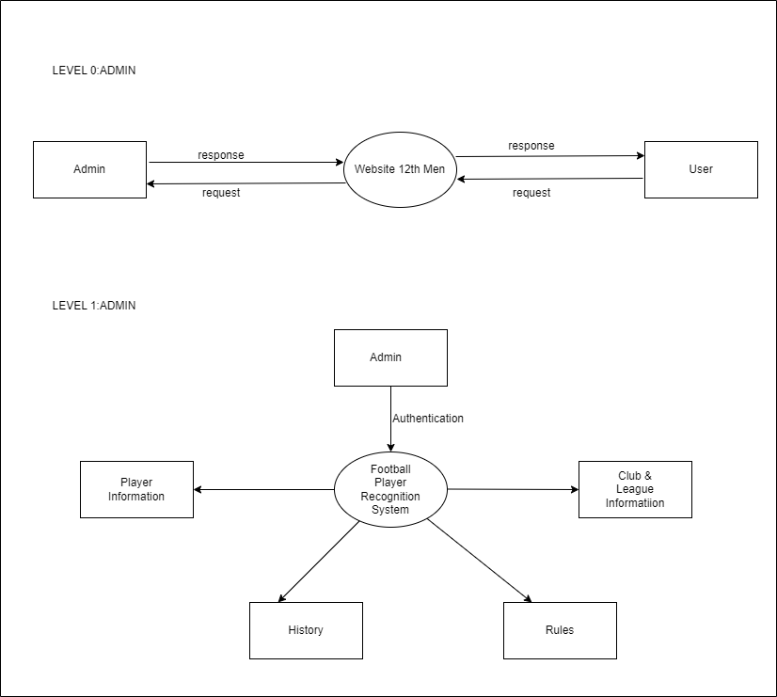**3.5.1 Data Flow Diagrams**

****Fig 3-6: DFD DIAGRAM (LEVEL 0) ADMIN**

**Fig 3-7: DFD DIAGRAM (LEVEL 1) ADMIN**

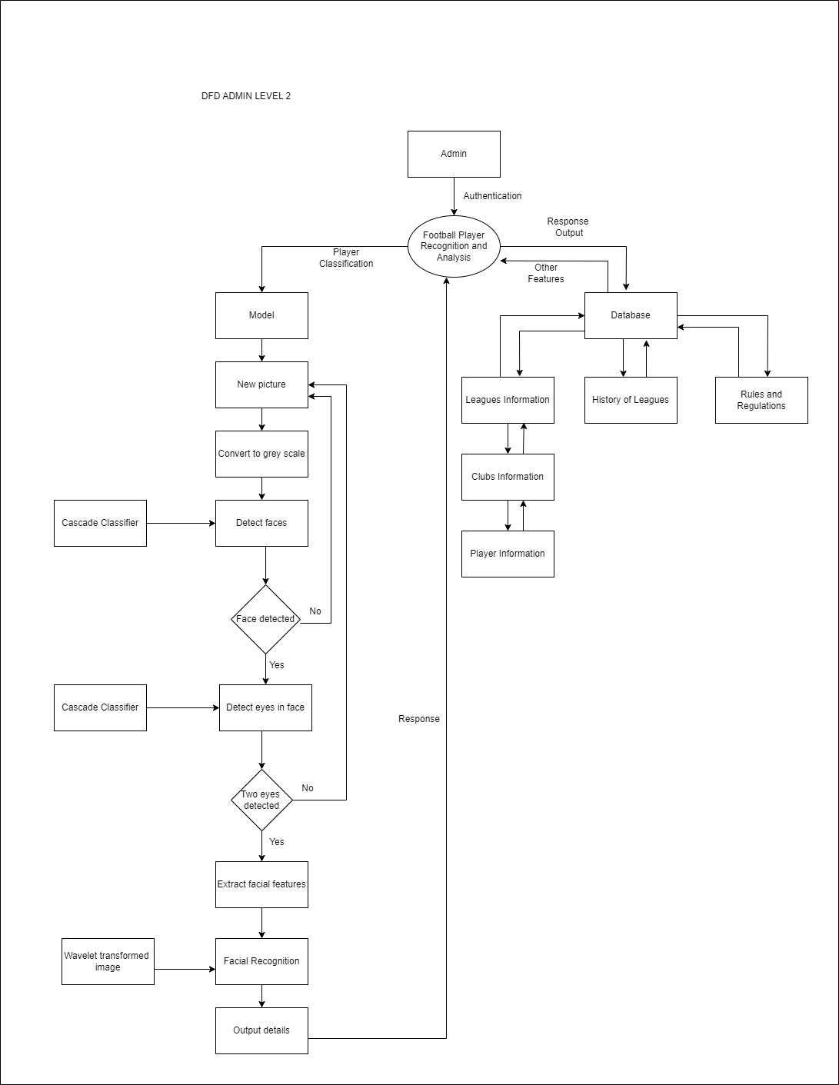

**Fig 3-8: DFD DIAGRAM (LEVEL 2) ADMIN**

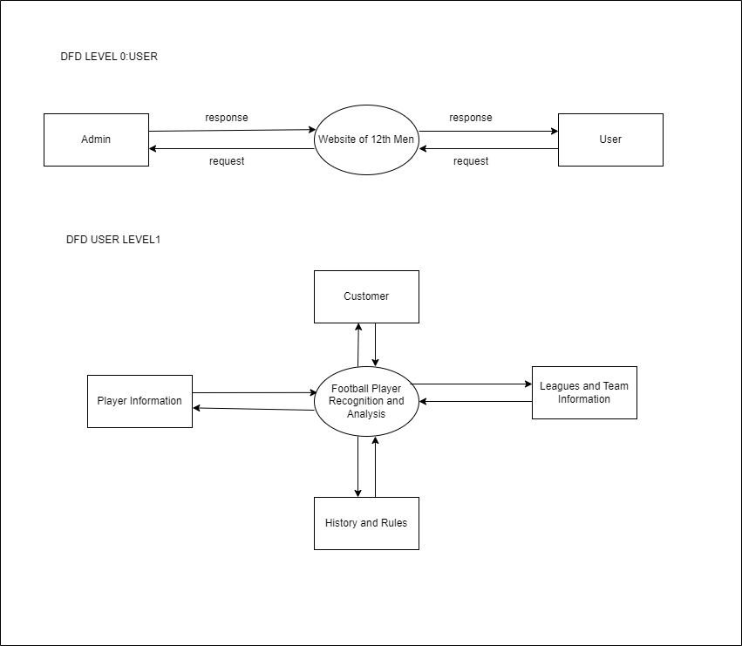

**Fig 3-9: DFD DIAGRAM (LEVEL 0) USER**



**Fig 3-10: DFD DIAGRAM (LEVEL 1) USER**

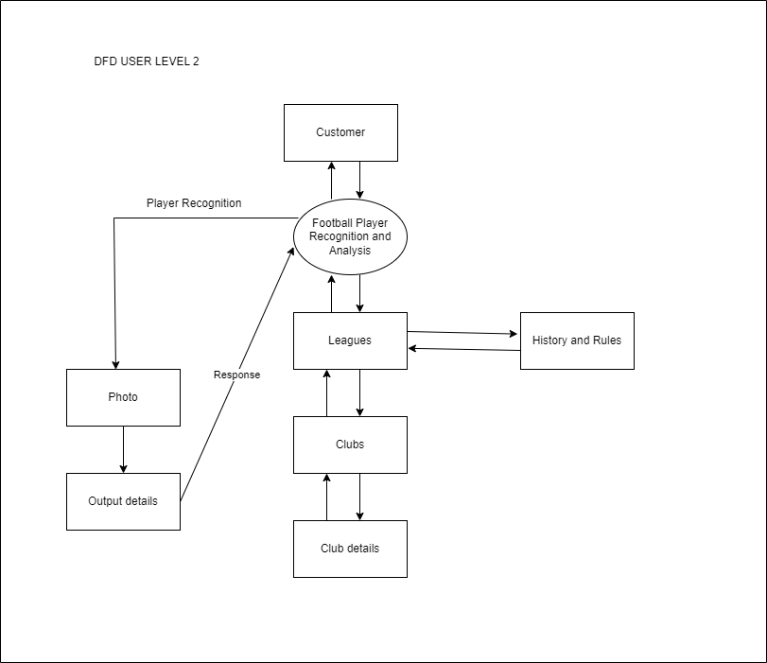

**Fig 3-11: DFD DIAGRAM (LEVEL 2) USER**

**3.5.2 E R Diagram**

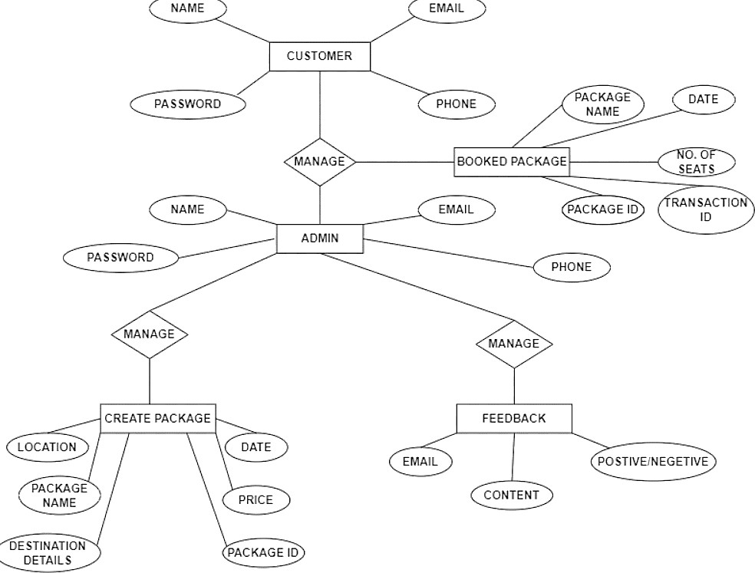

**Fig 3-11: ER Diagram**

**3.5.3 Use Case Diagram**

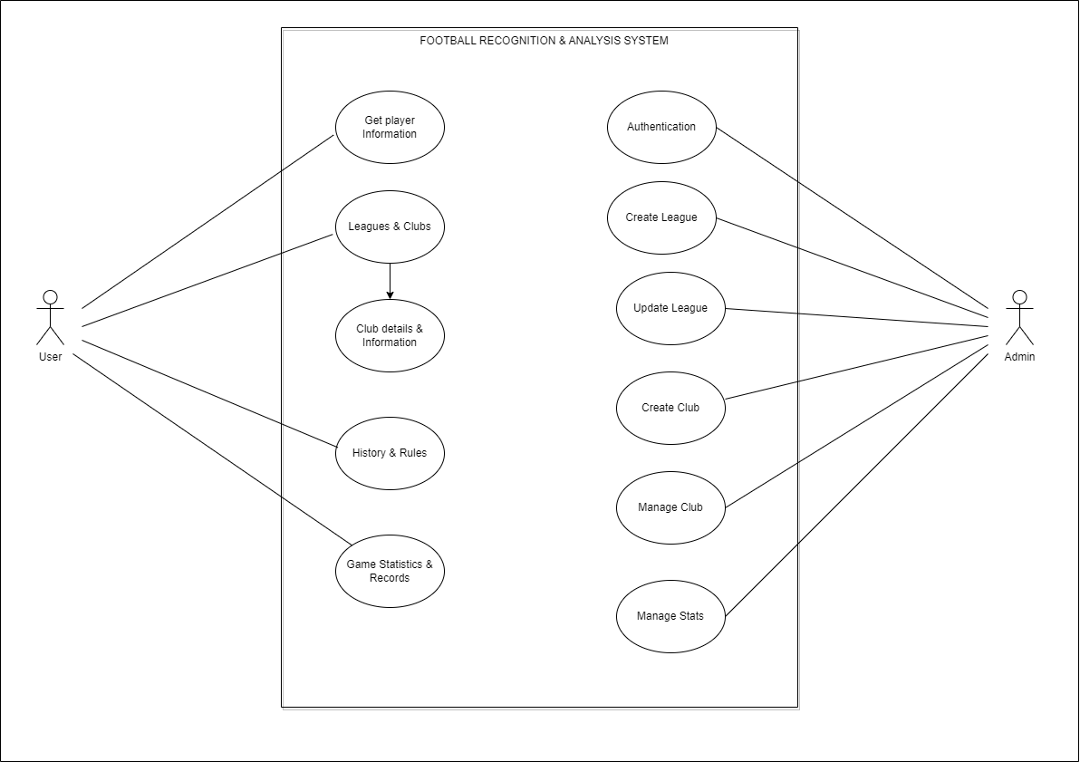

**Fig 3-12: Use Case Diagram**

**3.5.4 Activity Diagram**

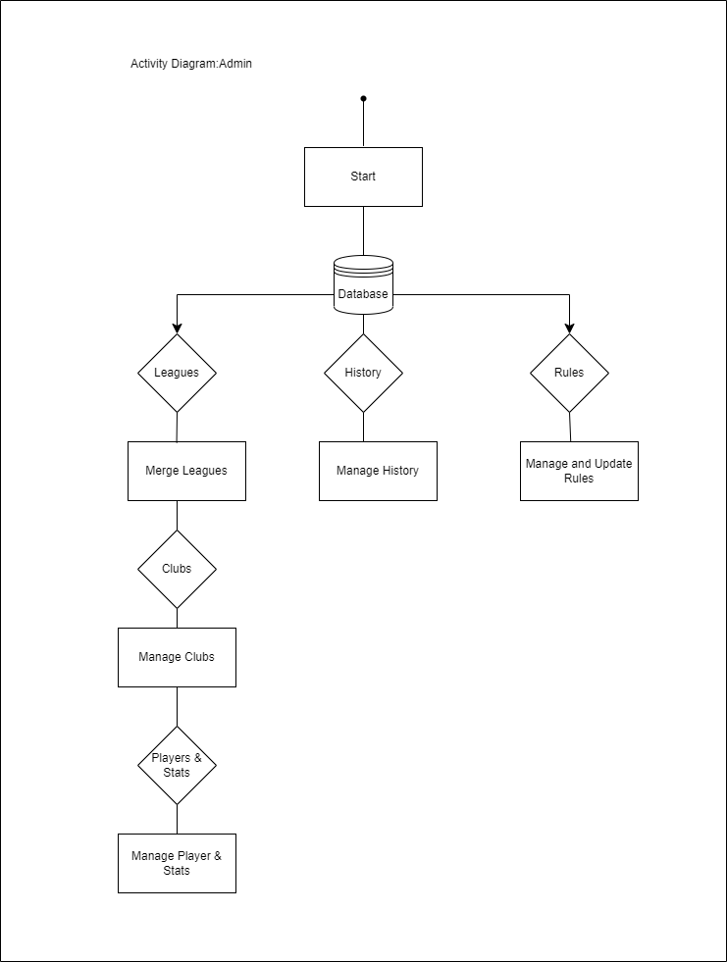

**Fig 3-13: Activity Diagram-ADMIN**

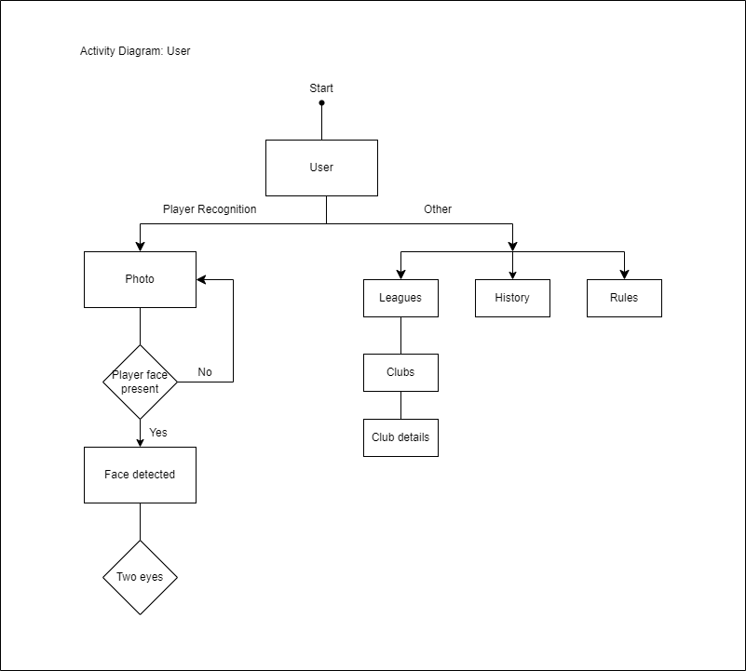

**Fig 3-13: Activity Diagram-USER**

**3.6 Deployment Requirements**

There are various requirements (hardware, software and services) to successfully deploy the system. These are mentioned below :

**3.6.1 Hardware**

* Processor: Minimum 1 GHz; Recommended 2GHz or more.
* Ethernet connection (LAN) OR a wireless adapter (Wi-Fi).
* Hard Drive: Minimum 32 GB; Recommended 64 GB or more.
* Memory (RAM): Minimum 1 GB; Recommended 4 GB or above.
* Backup Drive- Have backup drive for your computer to ensure that you don’t lose the investment you’ve made in your computer.

**3.6.2 Software**

* Basic Text or HTML Editor
* Web Browsers
* Graphics Editor
* FTP Client-Need an FTP (file transfer protocol) client to transfer your HTML files and supporting images and graphics to your web server.

**Chapter 4. Implementation**

Implementation

______________________________________________________________________________________________________________________________

In our country football is getting popular but most of the people didn't properly understand the game so it is hard for them to connect with the game. For example people doesn't know about different leagues and the clubs that play on these leagues so it is difficult to keep track of things. They are not fully aware of rules and regulations of the game and most of the times just know about one or two clubs and very limited no. of players.As a result of these they are not aware of the full potential, passion and joy of this game.

For the problem of maintaining and organizing a data of football players of all the leagues and clubs, the system is designed in such a way so as to automate the process by providing all the required information at a single place and user can easily access this just by uploading the image of the player with the help of our website.

**4.1 Technology Used**

**4.1.1 Front end-**

* **Bootstrap**



Bootstrap is a free and open-source CSS framework directed at responsive, mobile-first front-end web development. It contains HTML, CSS and (optionally) JavaScript-based design templates for typography, forms, buttons, navigation, and other interface components. Bootstrap is an HTML, CSS & JS Library that focuses on simplifying the development of informative web pages (as opposed to web apps). The primary purpose of adding it to a web project is to apply Bootstrap's choices of color, size, font and layout to that project. As such, the primary factor is whether the developers in charge find those choices to their liking. Once added to a project, Bootstrap provides basic style definitions for all HTML elements. The result is a uniform appearance for prose, tables and form elements across web browsers. In addition, developers can take advantage of CSS classes defined in Bootstrap to further customize the appearance of their contents. For example, Bootstrap has provisioned for light- and dark-colored tables, page headings, more prominent pull quotes, and text with a highlight.

* **HTML -**It stands for ‘HYPERTEXT MARKUP LANGUAGE’. HTML is a standardized system for tagging text files that creates the structure for just about every page that we find and use on the web. It’s HTML that adds in page breaks, paragraphs, bold lettering, italics, and more. HTML works to build this structure by using tags that tell browsers what to do with text.
* **CSS –** It stands for ‘CASCADING STYLE SHEET’. CSS is used for defining the styles for web pages. It describes the look and formatting of a document which is written in a markup language. It provides an additional feature to HTML. It is generally used with HTML to change the style of web pages and user interfaces. It is easier to make the web pages presentable using CSS. It is easy to learn and understand and used to control the presentation of an HTML document. CSS helps us to control the text color, font style, the spacing between paragraphs, sizing of columns, layout designs, and many more. It is independent of [HTML, and we can use it with any XML-based markup language.](https://www.javatpoint.com/html-tutorial)

It is recommended to use CSS because the [HTML attributes are being deprecated. So, for making HTML pages compatible with future browsers, it is good to start using CSS in HTML pages.](https://www.javatpoint.com/html-attributes)

* **[Javascript](https://www.javatpoint.com/html-attributes)** **-** JavaScript is a text-based programming language used both on the client-side and server-side that allows you to make web pages interactive. Where HTML and CSS are languages that give structure and style to web pages, JavaScript gives web pages interactive elements that engage a user.

**4.1.2 BACK-END –**

* **Node js –**



Node.js is a cross-platform, open-source server environment that can run on Windows, Linux, Unix, macOS, and more. Node.js is a back-end JavaScript runtime environment, runs on the V8 JavaScript Engine, and executes JavaScript code outside a web browser. Node.js lets developers use JavaScript to write command line tools and for [server-side scripting](https://en.wikipedia.org/wiki/Server-side_scripting). The ability to run JavaScript code on the server is often used to generate [dynamic web page](https://en.wikipedia.org/wiki/Dynamic_web_page) content before the page is sent to the user's web browser.

* **Python-**



Python is a high-level, general-purpose programming language. Its design philosophy emphasizes code readability with the use of significant indentation via the off-side rule.

Python is [dynamically typed](https://en.wikipedia.org/wiki/Type_system#DYNAMIC) and [garbage-collected](https://en.wikipedia.org/wiki/Garbage_collection_(computer_science)). It supports multiple [programming paradigms](https://en.wikipedia.org/wiki/Programming_paradigm), including [structured](https://en.wikipedia.org/wiki/Structured_programming) (particularly [procedural](https://en.wikipedia.org/wiki/Procedural_programming)), [object-oriented](https://en.wikipedia.org/wiki/Object-oriented_programming) and [functional programming](https://en.wikipedia.org/wiki/Functional_programming). It is often described as a "batteries included" language due to its comprehensive [standard library](https://en.wikipedia.org/wiki/Standard_library).

* 1. **Language Used**

Node js is used in the system due to the following characterstics :

1. **Asynchronous and Event-Driven:** The Node.js library’s APIs are all asynchronous (non-blocking) in nature. A server built with Node.JS never waits for data from an API. from an API. After accessing an API, the server moves on to the next one. In order to receive and track responses of previous API requests, it uses a notification mechanism called Events.
2. **Single-Threaded:** Node.js employs a single-threaded architecture with event looping, making it very scalable. In contrast to typical servers, which create limited threads to process requests, the event mechanism allows the node.js server to reply in a non-blocking manner and makes it more scalable. When compared to traditional servers like Apache HTTP Server, Node.js uses a single-threaded program that can handle a considerably larger number of requests.
3. **Scalable:** NodeJs addresses one of the most pressing concerns in software development: scalability. Nowadays, most organizations demand scalable software. NodeJs can also handle concurrent requests efficiently. It has a cluster module that manages load balancing for all CPU cores that are active. The capability of NodeJs to partition applications horizontally is its most appealing feature. It achieves this through the use of child processes. This allows the organizations to provide distinct app versions to different target audiences, allowing them to cater to client preferences for customization.
4. **Quick execution of code:**Node.js makes use of the V8 JavaScript Runtime motor, which is also used by Google Chrome. Hub provides a wrapper for the JavaScript motor, which makes the runtime motor faster. As a result, the preparation of requests inside Node.js becomes faster as well.
5. **Cross-platform compatibility:** NodeJS may be used on a variety of systems, including Windows, Unix, Linux, Mac OS X, and mobile devices. It can be paired with the appropriate package to generate a self-sufficient executable.
6. **Uses JavaScript:** JavaScript is used by the Node.js library, which is another important aspect of Node.js from the engineer’s perspective. Most of the engineers are already familiar with JavaScript. As a result, a designer who is familiar with JavaScript will find that working with Node.js is much easier.
7. **Fast data streaming:**When data is transmitted in multiple streams, processing them takes a long time. Node.js processes data at a very fast rate. It processes and uploads a file simultaneously, thereby saving a lot of time. As a result, NodeJs improves the overall speed of data and video streaming.
8. **No Buffering:** In a Node.js application, data is never buffered.

**4.4 Screenshots**

The Following are the screenshots of the result of the project :

**Fig 4-4: Package Details**

**Fig 4-5: Booking Info Page**

**Fig 4-6: Package Pending**

**Fig 4-7: Booking Confirmation**

**4.5 Testing**

Testing is the process of evaluation of a system to detect differences between given input and expected output and also to assess the feature of the system. Testing assesses the quality of the product. It is a process that is done during the development process.

**4.5.1 Strategy Used**

Tests can be conducted based on two approaches –

* Functionality testing
* Implementation testing

The texting method used here is Black Box Testing. It is carried out to test functionality of the program. It is also called ‘Behavioral’ testing. The tester in this case, has a set of input values and respective desired results. On providing input, if the output matches with the desired results, the program is tested ‘ok’, and problematic otherwise.

**4.5.2 Test Case and Analysis**

* **TEST CASE: 1**

|  |  |  |
| --- | --- | --- |
| Test Case ID | TC001 |  |
| Test Case Summary | Invalid Login Credentials Problem. Initially the login system was accepting invalid usernames (First name, Last name) it was accepting numbers in place of names so we find and dealt with it during the testing phase of the program. |  |
| Test Procedure | By using JavaScript validation system, we solved this problem of invalid login credentials. |  |
| Expected Result | First name and last name must be names and have a definite length. |  |
| Actual Result | First and last name must be names having minimum length of 3 letters and maximum 50. Email address provided should also be in valid form for registering to the portal. |  |
| Status | PASS |  |

**Table 4-1:Test Case 1**

**TEST CASE 1 OUTPUT**

**Fig 4-8: Test Case 1 Output**

* **TEST CASE: 2**

|  |  |  |
| --- | --- | --- |
| Test Case ID | TC002 |  |
| Test Case Summary | While creating new packages the uploaded photos of destination was not uploading to the portal. |  |
| Test Procedure | We created A new folder for the photos to be stored and the relative path was stored in the database. |  |
| Expected Result | Photos should be loading in webpage and showing to users after creation of any new package. |  |
| Actual Result | Photos were actually loading in the webpage and can be viewed by users. |  |
| Status | PASS |  |
|  | **Table 4-2: Test Case 2** |  |

**TEST CASE 2 OUTPUT**

**Fig 4-9: Test Case 2 Output 1**

**FINAL OUTPUT**

**Fig 4-10: Test Case 2 Output 2**

**Chapter 5 Conclusion**

Conclusion

­­­­­­­­­­­­­­__________________________________________________________________________________________________________________________________

**5.1 Conclusion**

We have proposed an efficient system which identify football players from the photograph and provide statistics of the players. Our system uses Open CV and Haar Cascade Classifier for the recognition of the player, with the advantages of giving information about the leagues and clubs and to fulfill our objective that is to create awareness and interest among youth about football through our website. Our results shows that the model can perform well on the dataset obtained from Kaggle, indicating the wide applications of this algorithm. Having done all above processes successfully, the model was able to identify players from the same team. Detection is just the beginning. Now we can really take it to the next level! We can now quickly analyze the course of the action, knowing how the ball traveled between players, count the distance the players traveled, or locate the field zones where they appeared most often.

**5.2 Limitations of the Work**

The acquired results during experiments are limited to some extent and may much vary depending on the experiment settings. One of its major demerits is it does not provide real time score of ongoing matches. And the photo required for player recognition must contain both eyes of that player to provide appropriate result. The stats provided about a player must be updated regularly.

**5.3 Suggestion and Recommendations for Future Work**

* The website interface would be more variant.
* Should be more informative.
* More number of player should be introduced .

**Bibliography**

1. J. T. Johnston, B. R. Mandelbaum, D. Schub et al., “Video analysis of anterior cruciate ligament tears in professional American football athletes,” The American Journal of Sports Medicine, vol. 46, no. 4, pp. 862–868, 2018.
2. I. McKeown, K. Taylor-McKeown, C. Woods, and N. Ball, “Athletic ability assessment: a movement assessment protocol for athletes,” International journal of sports physical therapy, vol. 9, no. 7, pp. 862–873, 2014
3. https://web.unibas.it/bloisi/corsi/progettivep/soccer-player-detection.html- Football and Computer vision
4. https://www.slideshare.net/RittwikAdhikari/football-player-detection-and-tracking
5. <https://wachemo-elearning.net/courses/football/lessons/chapter-one-history-of-football-game/topic/1-1-the-historical-background-of-football-game/>
6. https://www.goodhousekeeping.com/life/g34978833/best-football-quotes/?slide=1

**Source Code**

______________________________________________________________________________________________________________________________

<!DOCTYPE html>

<html lang="en">

<head>

<meta charset="UTF-8">

<meta http-equiv="X-UA-Compatible" content="IE=edge">

<meta name="viewport" content="width=device-width, initial-scale=1">

<title>12-th Man</title>

<link href="https://cdn.jsdelivr.net/npm/bootstrap@5.3.0-alpha1/dist/css/bootstrap.min.css" rel="stylesheet"

integrity="sha384-GLhlTQ8iRABdZLl6O3oVMWSktQOp6b7In1Zl3/Jr59b6EGGoI1aFkw7cmDA6j6gD" crossorigin="anonymous">

<link rel="stylesheet" href="https://cdnjs.cloudflare.com/ajax/libs/font-awesome/6.3.0/css/all.min.css">

<link rel="stylesheet" href="css/style.css">

</head>

<body>

{{>navbar}}

<!-- carousel section start-->

<div class="bgImg">

<div id="carouselExampleFade" class="carousel slide carousel-fade">

<div class="carousel-inner">

<div class="carousel-item active">

<img src="./img/deepMessiBg.jpg" class="w-100" alt="...">

<!-- <img src="./img/messi bg.jpg" class="w-100" alt="..."> -->

</div>

<div class="carousel-item">

<!-- <img src="./img/ronaldo bg.jpg" class="w-100" alt="..."> -->

<img src="./img/deepRonaldoBg.jpg" class="w-100" alt="...">

</div>

<div class="carousel-item">

<img src="./img/deepMbBg.jpg" class="w-100" alt="...">

<!-- <img src="./img/mbaapebg.jpg" class="w-100" alt="..."> -->

</div>

<div class="carousel-item">

<img src="./img/deeepNeymarBg.jpg" class="w-100" alt="...">

<!-- <img src="./img/messibg3.jpg" class="w-100" alt="..."> -->

</div>

<!-- <div class="carousel-item">

<img src="./img/ronaldobg2.jpg" class="w-100" alt="...">

</div>

<div class="carousel-item">

<img src="./img/mbaapebg2.jpg" class="w-100" alt="...">

</div> -->

</div>

<button class="carousel-control-prev" type="button" data-bs-target="#carouselExampleFade"

data-bs-slide="prev">

<span class="carousel-control-prev-icon" aria-hidden="true"></span>

<span class="visually-hidden">Previous</span>

</button>

<button class="carousel-control-next" type="button" data-bs-target="#carouselExampleFade"

data-bs-slide="next">

<span class="carousel-control-next-icon" aria-hidden="true"></span>

<span class="visually-hidden">Next</span>

</button>

</div>

</div>

<!-- carousel section End-->

<!-- IMG UPLOAD SECTION -->

<div class="img-upload">

<form action="" method="post">

<label for="upload" class="upload">

<input type="file" id="upload" accept=".jpg,.png" enctype="multipart/form-data">

<i class="fa-solid fa-file-import"></i>

<span>Choose Image</span>

<div class="form-check">

<input class="form-check-input" type="checkbox" value="" id="flexCheckDefault" disabled>

<span id="img-name">Image Uploaded</span>

</div>

</label>

<input type="submit" value="Search" class="sbtn" disabled>

</form>

</div>

<!-- IMG UPLOAD SECTION END-->

<!-- footer -->

<footer>

<p> Copyright &copy; www.The 12th Man.com All rights reserved</p>

</footer>

<script src="https://cdn.jsdelivr.net/npm/bootstrap@5.3.0-alpha1/dist/js/bootstrap.bundle.min.js"

integrity="sha384-w76AqPfDkMBDXo30jS1Sgez6pr3x5MlQ1ZAGC+nuZB+EYdgRZgiwxhTBTkF7CXvN"

crossorigin="anonymous"></script>

<script src="./js/index.js"></script>

</body>

</html>